
Whingate Primary School – Science
States of matter |   Year 4
What should I already know? |  | Vocabulary |  | Diagrams |  | Learning Journey  Assessment
-Know the difference between an object and the material from which it is made.  -Identify and name a variety of everyday materials, including wood, plastic, glass, metal, water, and rock.  -Describe the physical properties of a variety of everyday materials.  -Compare and group together a variety of everyday materials based on their physical properties.  -Identify and compare the suitability of a variety of everyday materials, including wood, metal, plastic, glass, brick, rock, paper and cardboard for particular uses.  -Find out how the shapes of solid objects made from some materials can be changed by squashing, bending, twisting and stretching. |  | Solids are objects that have a fixed shape.  Liquids are fluids that can change shape when poured but have the same volume.  Gases are substances that have no fixed size or shape.  Particles are the smallest possible units of matter.  Evaporation is when a liquid heats up to become a gas.  Condensation is when a gas cools to become a liquid.  Freezing is when a liquid cools to become a solid.  Melting is when a solid is heated to become a liquid. |  | States of Matter  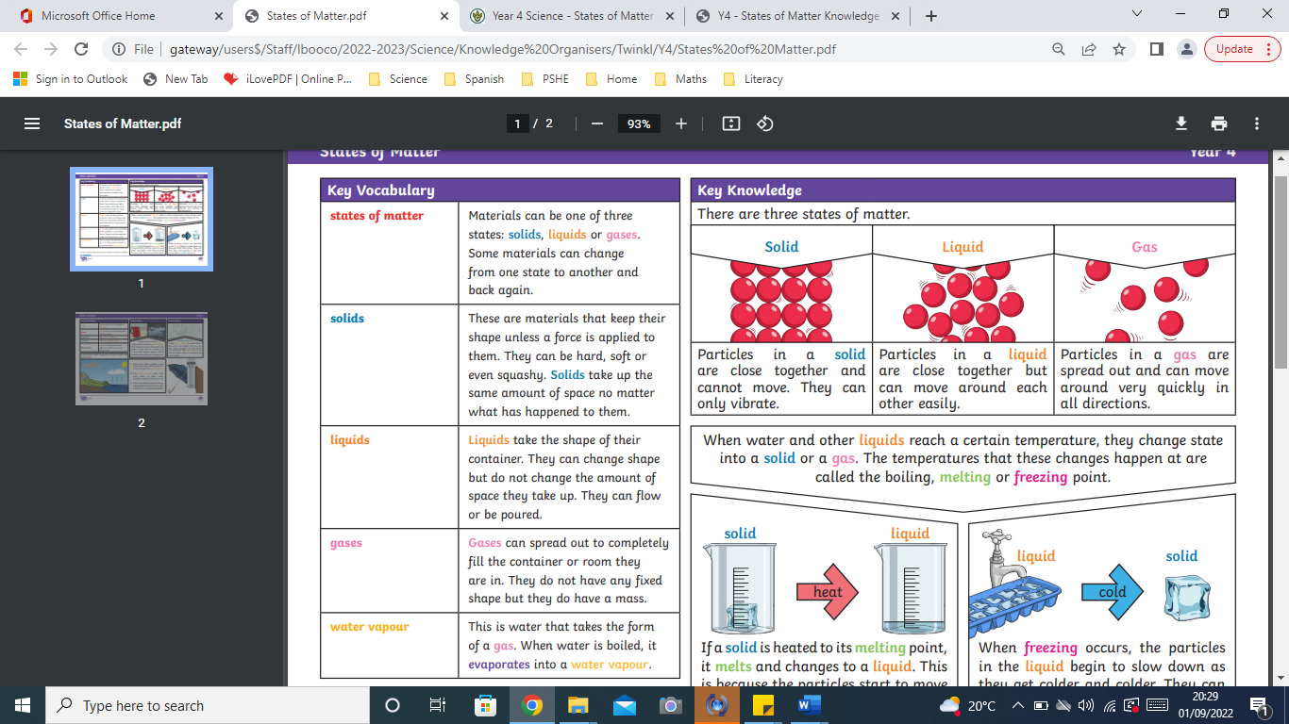  Heating and Cooling  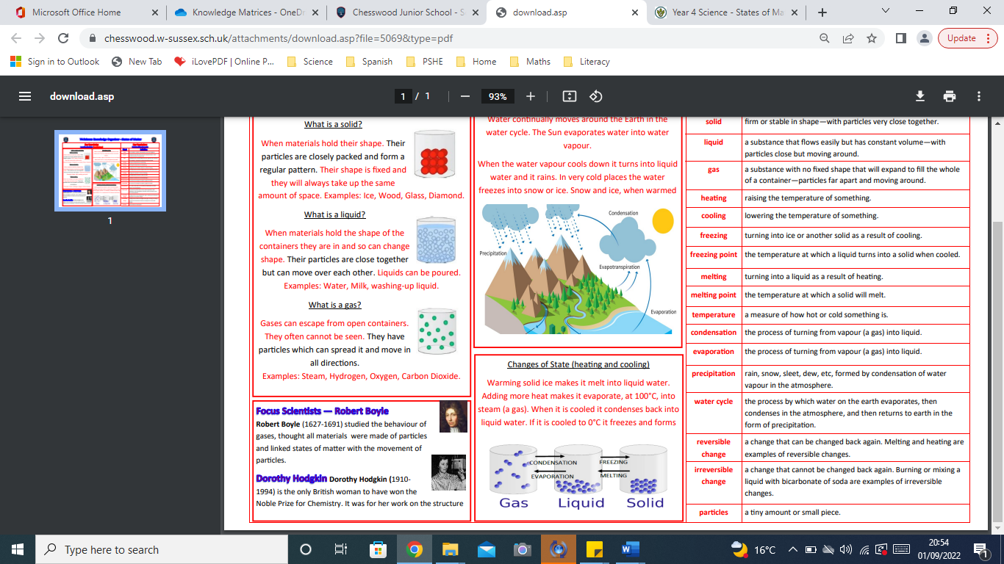  The Water Cycle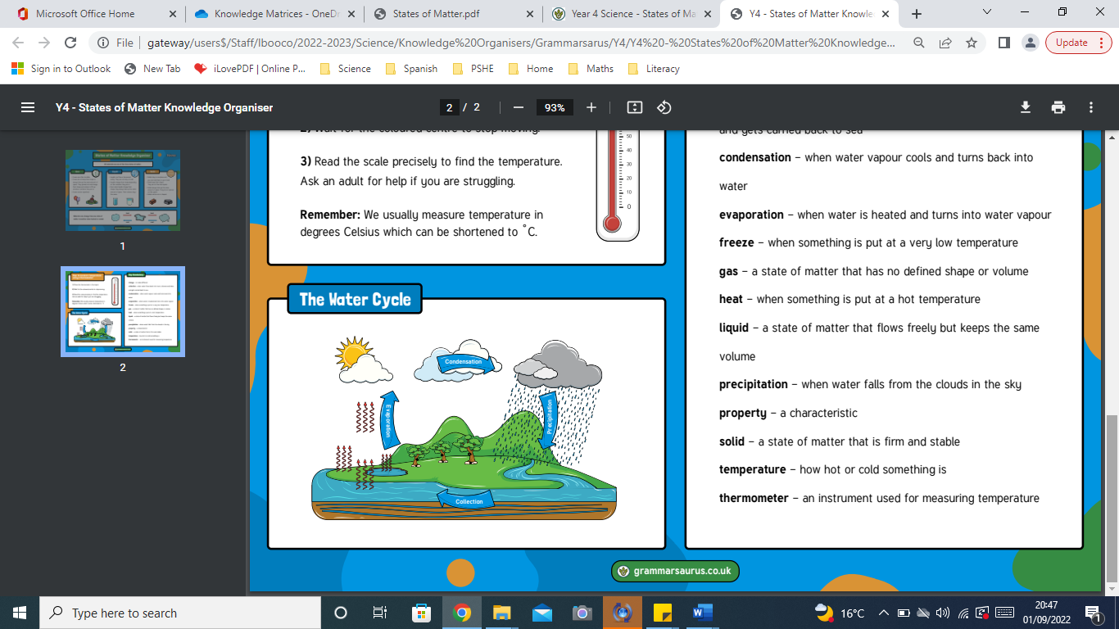 |  | -Compare and group materials together, according to whether they are solids, liquids or gases.  -Observe that some materials change state when they are heated or cooled, and measure or research the temperature at which this happens in degrees Celsius (°C).  -Identify the part played by evaporation and condensation in the water cycle and associate the rate of evaporation with temperature.
What will I know by the end of this unit?
- Group and compare materials different materials. Solid materials keep their shape. Liquids run or flow, they take the shape of their container and are not rigid.
- Gas matter can expand and flow, if gas is put in an unsealed container it can escape.
- Condensation is a part in the water cycle where water vapour (a gas) turns back into a liquid.
- Evaporation is when water is heated up, it changes state and becomes a gas called steam, this process is called evaporation.

 |  |  |  |  |  | Famous Scientists/Inventors
-Antoine Lavoisier and Joseph Priestley – two scientists responsible for the discovery of oxygen.
-Washington Sheffield – invented toothpaste.
-Garrett Morgan – invented the first modern gas mask.
-Robert Boyle – studied the behaviour of gases and linked states of matter with the movement of particles.

