
Whingate Primary School – Science
Light – Can humans see in the dark? |   YEAR 6

Interesting Fact 1: | Interesting Fact 2: | Interesting Fact 3: | Your answer to our topic question:
Visible light travels almost 186,282 miles per second through space. | The human eye can detect 10 million different colours. | Eyes perceive things upside down.

Diagrams: | Vocabulary: | What we will learn in this unit (skills):
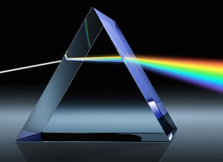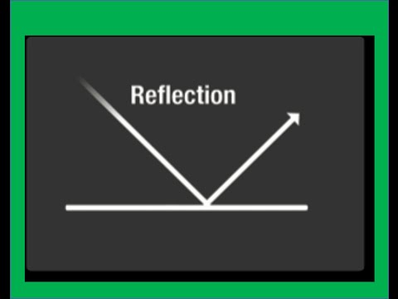  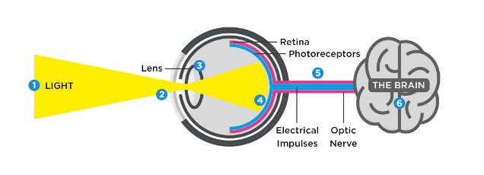 | beam – a line of light or particles.  dispersion – the separation of white light into colours.  light source – anything which makes light, either natural or artificial.  periscope – a device consisting of a long tube containing mirrors that enables the user to see over the top of something.  rainbow – an arch of colour in the sky caused by the refraction and dispersion of light by rain or other water droplets in the atmosphere.  reflection -  refraction -  shadow -  spectrum – a band of coloured light as seen in a rainbow. | We will:  Ask questions - Recognise scientific questions which do not yet have definitive answers and use a range of scientific enquiries to explore possible answers.  Make predictions - Identify scientific evidence that has been used to support or refute ideas or arguments and use this to support predictions.  Record data - Record data and results of increasing complexity using classification keys.  Draw conclusions - Provide straightforward explanations for differences in repeated measurements or observations.
Sticky Knowledge: |  | What we will learn in this unit (knowledge):
- Light travels in straight lines.  - Objects are seen because they give out light or reflect light into our eyes.  - Shadows have the same shape as the objects that cast them. |  | We will:  - recognise that light appears to travel in straight lines.  - use the ideas that light travels in straight lines to explain that objects are seen because they give out or reflect light into the eye.  - explain that we see things because light travels from light sources to our eyes or from light sources to objects and then to our eyes.  - use the idea that light travels in straight lines to explain why shadows have the same shape as the objects that cast them.
Assessment - Fill in the gaps:
______________ is the bending of light whereas ____________ is the throwing back of light from a surface.

A ____________ is a dark are or space coming between a light source and an object.

