
Whingate Primary School – Science
Animals including Humans |   YEAR 6

Interesting Fact 1: | Interesting Fact 2: | Interesting Fact 3: | Interesting Fact 4: | Your Interesting Fact:
A person’s blood vessels could wrap around the Earth about two and a half times. | The circulatory system was studied as far back as the Ancient Egyptians! | The human heart beats around 100,000 times per day and pumps 1.5 gallons of blood every minute. | Even though your veins are usually a blue colour, the blood is still red! Can you find out why?
What we will learn in this unit (skills): | Vocabulary: | Diagrams:
We will:  Ask questions - Recognise scientific questions which do not yet have definitive answers and use a range of scientific enquiries to explore possible answers.  Make predictions - Identify scientific evidence that has been used to support or refute ideas or arguments and use this to support predictions.  Record data - Record data and results of increasing complexity.  Draw conclusions - Provide straightforward explanations for differences in repeated measurements or observations. | aorta: The main artery through which blood leaves your heart before it flows through the rest of the body.  arteries: A tube in your body that carries oxygenated blood from your heart to the rest of your body.  atrium: An upper chamber in the heart.  blood vessels: The narrow tubes through which your blood flows. Arteries, veins and capillaries are blood vessels.  capillaries: Tiny blood vessels in your body.  carbon dioxide: A gas produced by animals and humans breathing out.  circulatory system: The system responsible for circulating blood through the body.  deoxygenated: Blood that does not contain oxygen.  heart: The organ in your chest that pumps blood around the body.  lungs: Two organs in your chest which fill with air when you breathe in. They oxygenate the blood.  nutrients: Substances that help living things grow.  oxygen: A colourless gas needed for survival.  oxygenated: Blood that contains oxygen.  respiration: The process of respiring / breathing (inhaling and exhaling air).  veins: A tube in your body that carries deoxygenated blood to your heart.  vena cava: A large vein through which your heart receives deoxygenated blood from the body.  ventricle: A lower chamber in the heart. | 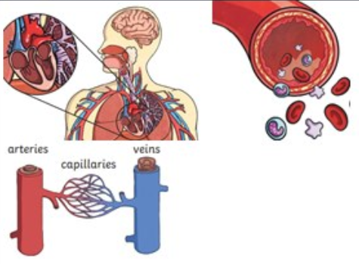
What we will learn in this unit (knowledge): |  | Sticky Knowledge:
We will learn that the circulatory system is made of the heart, veins arteries and capillaries.  We will be able to describe the process of how arteries carry oxygenated blood from the heart to the rest of the body and how veins carry blood from the body to the heart.  We will be able to describe the differences between arteries, capillaries and veins and discuss the four components which made up our blood.  We will be able to make prediction, investigate and form conclusions on the effects exercise can have on heart rate whilst understanding the importance of making positive lifestyle choices. |  | - To know that the circulatory system includes the heart and blood vessels.  - To know that blood transports oxygen, carbon dioxide, nutrients and waste.  - To know the functions of the red and white blood cells, as well as platelets and plasma.  - To know that leading a healthy lifestyle through exercise and a balanced diet can support the function of the heart.  - To know that drugs and alcohol can impact negatively on our bodies.

