
Whingate Primary School – Geography
Climate Change |   YEAR 6

Interesting Fact 1: | Interesting Fact 2: | Interesting Fact 3: | Interesting Fact 4: | Your Interesting Fact :
The last decade was the hottest is 125,000 years. | We are losing 1.2 trillion tons of ice each year. That is the same weight as all living things on Earth! | It could become too hot to live in many places on Earth by the end of the century. | The Golden Toad is the first species to go extinct due to climate change.

What we will learn in this unit (skills): | Vocabulary: | Diagrams:
We will:  - Use world maps, atlases and globes to locate physical features (climate zones)  - Ask and answer questions that are more causal e.g. Why is that happening in that place? Could it happen here? What happened in the past to cause that? How is it likely to change in the future?  - Identify and explain increasingly complex geographical features, processes (changes), patterns, relationships/ ideas.  - Use precise geographical language relating to human and physical processes  - Develop their views and critically evaluate responses to geographical issues or events. | biome – regions of the world with similar climate, animals and plants.  carbon – (dioxide) gas released into the atmosphere, associated with climate change.  climate – the weather conditions and temperature in an area over a long period of time.  climate zone – areas with a distinct climate (4 main zones on Earth: tropical, dry, temperate, continental, polar).  climate change – ……………………………………………………………  ……………………………………………………………………………………………  ……………………………………………………………………………………………  greenhouse effect – the way in which heat is trapped close to Earth’s surface by greenhouse gases.  non-renewable energy – energy from sources that will run out or not be replenished in our lifetime (e.g. fossil fuels such as coal, oil, gas).  renewable energy – energy from a source that is not depleted when used (e.g. solar, wind, hydro).  weather – the state of the atmosphere at a particular place and time (e.g. heat, rain, cloud). | 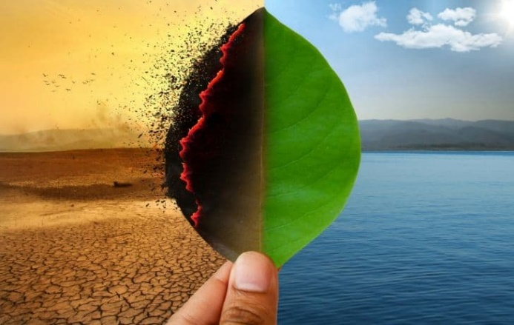
What we will learn in this unit (knowledge): |  | Sticky Knowledge:
- Identify all lines of latitude and longitude and identify key features of climate zones.  - Investigate vegetation belts and their key features.  - Study key aspects of human geography including types of settlement and land use. |  | -To understand how geographical regions and land use have changed over time.  -To know why industrial areas and ports are important.

