
Whingate Primary School – Art
Artist Focus: Stephen Wiltshire |   Developing Depth and Dimension

Interesting Fact 1: | Interesting Fact 2: | Interesting Fact 3: | Interesting Fact 4: | Interesting Fact 5:
He was known as ‘possibly the best child artist in Britain’ | Sold his first piece of art to the British Prime Minister at age 8. | Wiltshire is autistic and didn’t communicate through speech until age 9. | Has travelled the world creating and selling his artwork. | ____________________________  ____________________________

What we will learn in this unit: | Vocabulary: | Images:
- develop an understanding about the style of Stephen Wiltshire’s art  - recognise key features of John Dyer’s artwork  - use a single material to create art  - how to develop tone and depth in a line drawing  - how to use simple shapes to create sketches  - how to create art inspired by the work of Stephen Wiltshire | Figurative art - the opposite of abstract art. It shows clear and direct shapes that people can link to real-life things.  Autism - Autism Spectrum Disorder (ASD), usually called autism, is something you're born with. Autism means that the way you think about and experience the world is different to most people. This means you can behave differently to most people and have different strengths and difficulties.  Cityscape - In the visual arts, a cityscape is an artistic representation, such as a painting, drawing, print or photograph, of the physical aspects of a city.  Landmark - an object or feature of a landscape or town that is easily seen and recognized from a distance, especially one that enables someone to establish their location.  Exhibition - a public display of works of art or items of interest, held in an art gallery or museum or at a trade fair. | 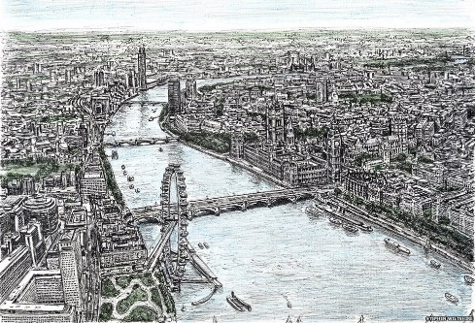  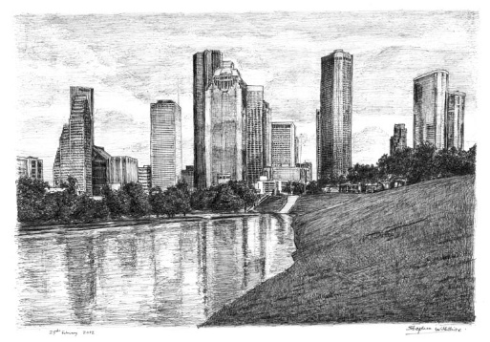  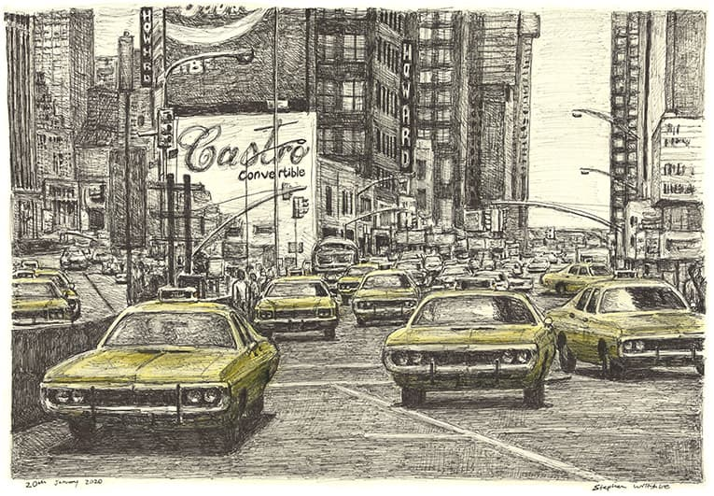
Stephen Wiltshire - Artist
