
Whingate Primary School – Science
Living Things and their Habitats |   YEAR 6

Interesting Fact 1: | Interesting Fact 2: | Interesting Fact 3: | Interesting Fact 4: | Your Interesting Fact :
Scientists estimate that Planet Earth is home to 8.7 million different species. | Aristotle (384BC-322BC) was the first person to try and classify living things into groups. | Carolus Linnaeus (1707-1778) made it his life’s work to develop a way to classify and name all life on Earth | There are seven divisions in the system: Kingdom, Phylum, Class, Order, Family, Genus, Species

Diagrams: | Vocabulary: | What we will learn in this unit (skills):
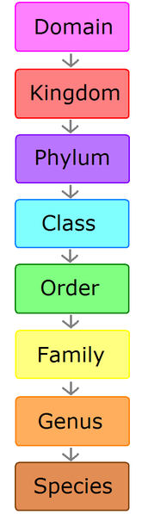  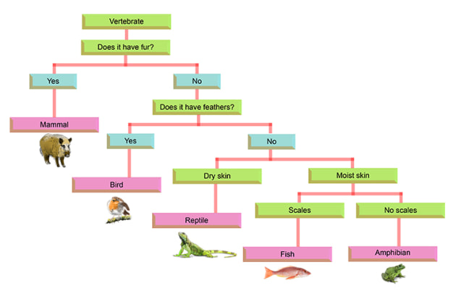 | amphibians - A cold-blooded vertebrate animal.  arthropod – An invertebrate animal with an exoskeleton.  bird - A warm-blooded egg-laying vertebrate animal.  classification - The arrangement of animals and plants in taxonomic groups according to their observed similarities.  distinguish - To recognise or understand the difference between two things, or to provide a quality that makes something different or special.  fish - A limbless cold-blooded vertebrate animal with gills and fins living wholly in water.  insect - A small arthropod animal that has six legs and generally one or two pairs of wings.  invertebrate - An animal lacking a backbone.  mammal – A warm-blooded vertebrate animal  microorganism - a microscopic organism  reptiles - vertebrate animals.  taxonomic - Concerned with the classification of things, especially organisms.  organism - An individual animal, plant, or single-celled life form.  vertebrate – An animal distinguished by the possession of a backbone or spinal column. | We will:  Ask questions - Recognise scientific questions which do not yet have definitive answers and use a range of scientific enquiries to explore possible answers.  Make predictions - Identify scientific evidence that has been used to support or refute ideas or arguments and use this to support predictions.  Record data - Record data and results of increasing complexity using classification keys.  Draw conclusions - Provide straightforward explanations for differences in repeated measurements or observations.
Sticky Knowledge: |  | What we will learn in this unit (knowledge):
- Living things can be classified into four broad groups: invertebrates, vertebrates, plants, and micro-organisms. These groups are further sub-divided.  - We can identify an unknown plant or species using their characteristics. |  | -Describe how living things are classified into broad groups according to common observable characteristics and based on similarities and differences, including micro-organisms, plants and animals.  - Give reasons for classifying plants and animals based on specific characteristics.  - Explain who Carl Linnaeus was and his influence in scientific classification.
Assessment (Fill in the gaps):
A ____________________ is an animal of a large group distinguishes by the presence of a backbone.

An __________________ is an animal lacking a backbone.

