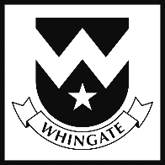
Long Term Plan 2023 – 2024
Year 6
Subject | Autumn 1 | Autumn 2 | Spring 1 | Spring 2 | Summer 1 | Summer 2
Learning Journey Title | WWII: The Blitz   | North America  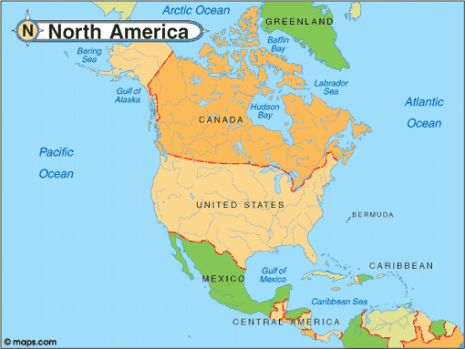 | Living Things  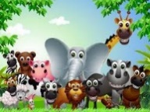 | Anglo Saxons and Vikings  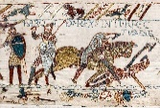 | Asia  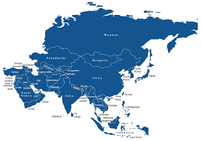 | The Caribbean  
Reading | -Active reading skills- recap.  -Hour long session: various WWII texts  Texts:  The Nowhere Emporium  The Midnight Guardians  Saffiyah’s War  The Lion Above the Door | -Active reading skills-  *Justify  *Inference  -Hour long session: various non-fiction texts  Texts:  Holes  Can you See Me? | -Active reading skills-*Summary  *Inference  *PEE  [poetry]  -Hour long session: various non-fiction texts  Texts:  Continue text from prev half term as class novel | -Active reading skills-  *gap focus  -Hour long session: various non-fiction texts related to animals  Texts:  The 1000-year-old boy | -SATs Skills  -Active reading  -Hour long session: various non-fiction texts related to animals  Texts:  Isha and The Spirit Bird | -Active reading skills-Justify  -Inference  [various fiction texts depended upon the cohort]  -Hour long session: various fiction texts  Texts:  The Final Year  or  TBC by Child Choice
Writing | Sentence Structure: Mini Unit  [Lighthouse and Dreamgiver]  Writing to Inform  [WWII] | Writing to Entertain  [Chaperon Rouge] | Writing to Persuade  [Conservation /Habitats/ Climate Change] | Writing to Discuss  [Three Little Pigs? Current Affairs] | Writing to…  Text driven and Lit Shed units | Writing to…  Text driven and Lit Shed units
Maths | -Place Value  - Addition, subtraction, multiplication and division  - Consolid. | - Fractions A  - Fractions B  - Converting measures  - Consolid. | - Ratio  - Algebra  - Decimals  - Consolid. | - FDP  - Area, perimeter and volume  - Statistics  - Consolid. | - Shape  - Position and direction  - Consolid. | -Review and consolidation
Science | Light | Electricity | Living Things | Animals Including Humans | Animals Including Humans | Evolution & Inheritance
History | The Blitz  BHM | N/A | N/A | Anglo Saxons and Vikings to 1066 | N/A | Indus Valley
Accept and Respect | Black History Month (Oct) | Christmas (Dec) | ? | Womens History Month (March) | ? | ?
Geography | N/A | North America | N/A | Climate Change | Local Walk (fieldwork) | The Caribbean
Art | Artist Focus – Stephen Wiltshire Shading, shadow and silhouette | N/A | Artists (John Dyer) |  | Textures (Lino printing)
DT | N/A | Structures | N/A | Textiles | N/A | Cooking [Bake Off – Bread]
Music | Hey Mr Miller (Sing Up)  Swing Music | Playing Xmas Songs (learning to play a tuned instrument – glockenspiel) | Shadows (Sing Up)  Comparing musical genres | You To Me Are Everything (Sing Up)  1970s Soul / Comparing cover versions | N/A | Ame Sau Vala Tara Bal – Exploring (Sing Up)  Comparing Indian Musical Styles
RE | How do Sikhs show commitment | What do Christians believe about Jesus’ death and resurrection? | How do Jews remember Kings and Prophets in worship & life? |  | How does growing up bring responsibility?
PSHE | Mental Health and Emotional Wellbeing | Drug and Alcohol Education | Identity, society and equality | Keeping safe and managing risk | RHSE  Mental Health and Emotional Wellbeing recap and development | RHSE and FGM  Transition
MfL | ¡Hola! ¿Que tal? (Greetings and saying how you feel)  Vamos a contar (Counting t0 15 and saying your age) | Los colores (Using ser to say what colour something is)  En mi estuche (Gender of singular nouns using school equipment) | Mi familia y yo (My family and I) | En el parque de animals (Numbers 1-39 and wild animals) | ¿A que fecha estamos? (Months, birthdays, days and dates) | ¿Tienes hambre? (Opinions of food)  ¿Que tiempo hace? (Weather, compass points and towns)
Computing | - Digital Literacy |  | - Information Technology |  | -Computer Science
PE | - Fitness/ Circuits.  - Hockey | - Gymnastics  - Basketball | - Gymnastics  - Dodgeball | - Dance  - Tennis | - Yoga  - Tag Rugby | - Athletics  - Cricket

