WHOLE SCHOOL LONG TERM PLAN 2025 – 2026

 | Autumn 1 | Autumn 2 | Spring 1 | Spring 2 | Summer 1 | Summer 2
FS | The Seaside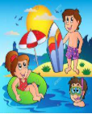 | Under the Stars | Big and Small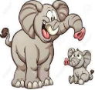 | Build it Up | Wonderful Water | It’s Magic
Year 1 |   Our World and Me |   Changes | Weather and Seasons   | Dinosaurs   | Growing   | Under the Sea  
Year 2 | Animals  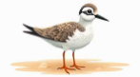 | Great Fire of London  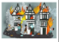 |   Dragons | Climate Changes  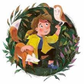 | Famous People   | Adventures  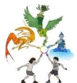
Year 3 |   Back in Time |   Our Planet | Ancient Egypt  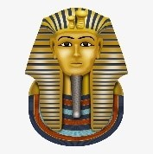 | Natural Disasters  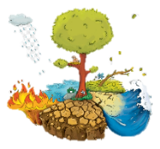 | Rome  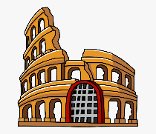 | Africa  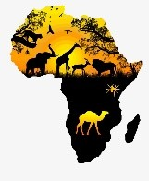
Year 4 |   King and Queens | 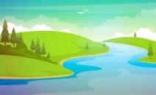  Water and Rivers | The Mayans  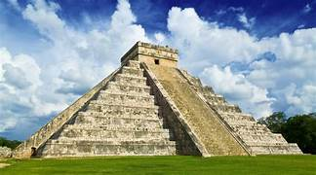 | Mexico  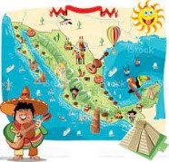 | Arthurian Legends  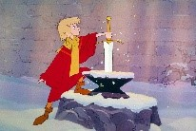 | The Amazon  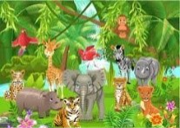
Year 5 | Mountains  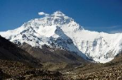 | Victorian Britain  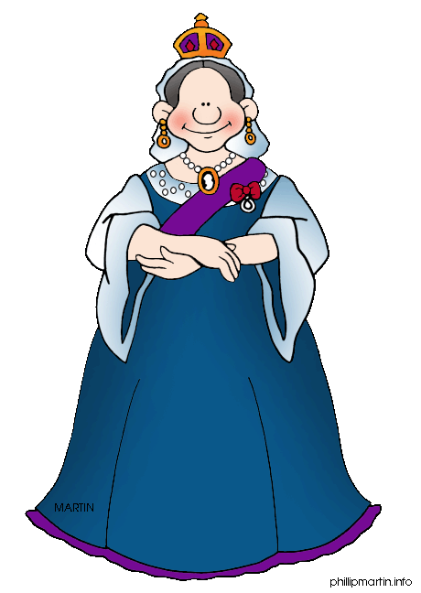 | Armley in the Industrial Revolution  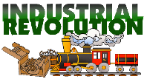 | Journey into Space  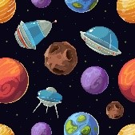 | Ancient Greece   |   Modern Greece
Year 6 | WWII: The Blitz   | 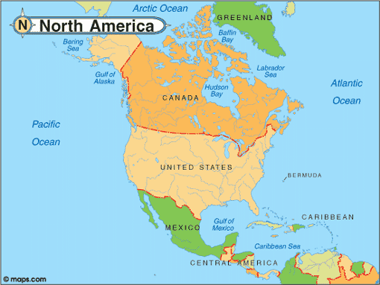  North America | 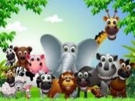  Living Things | Anglo Saxons and Vikings  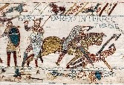 | 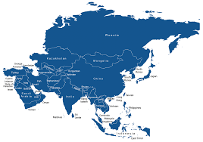  Asia | 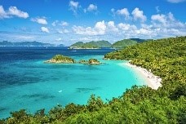  The Caribbean

